**Cortical Damage and Disconnection Contribute to Post-Stroke Sensorimotor Impairment**

by

Shafagh Yazdani

Bachelor of Science

University of Tehran, 2009

Submitted in Partial Fulfillment of the Requirements

For the Degree of Master of Science in

Exercise Science

Norman J. Arnold School of Public Health

University of South Carolina

2018

Accepted by:

Troy M. Herter, Director of Thesis

Stacy L. Fritz, Committee Member

Roozbeh Behroozmand, Committee Member

Lacy Ford, Vice Provost and Dean of Graduate Studies

© Copyright by Shafagh Yazdani, 2016

All Rights Reserved.

**Dedication**

To my parents, my husband, and my brother.

**Acknowledgments**

I would like to express my great appreciation to all of those who put in time and energy to help, support, and guide me. A special thanks to my advisor, Dr. Troy Herter, who patiently guided me along in my studies and research, supported me to attend conferences and presentations, and helped me in the arduous process of completing my dissertation. He has set an example of excellence as a researcher, mentor, instructor, and role model. I also would like to thank Dr. Grigori Yourganov, who helped me tremendously by teaching me the fundamentals of MRI and neuroimaging analyses. I would also like to thank Dr. Stacy Fritz and Dr. Roozbeh Behroozmand for serving on my dissertation committee and mentoring me in the formative stages of my dissertation. I would like to thank the members of the different research groups in Department of Exercise Science at the University of South Carolina, including Dr. Jill Stewart, Dr. Tarkeshwar Singh, Chris Perry, and Adam Harrison. I would like to thank all my friends in Columbia, South Carolina, who have been like a family to me. Last, but not least, I would like to thank my husband who has patiently supported me throughout my studies, my parents who dedicated their lives to the well-being of their children, and my brother.

**Abstract**

**BACKGROUND.** Stroke is a cerebrovascular event that causes permanent damage to brain regions and decreases in connectivity (disconnection) between brain regions. Most stroke survivors have permanent difficulties performing functional motor tasks, thus research into how damage and disconnection produce difficulties performing motor tasks can help guide post-stroke rehabilitation. Previous studies have examined the extent to which cortical damage produces motor impairments, but the extent to which disconnection produces motor impairments remains unclear. Furthermore, studies have focused on how motor impairments contribute to difficulties performing motor tasks, whereas the role of visuospatial impairments has received little attention. Neuroimaging techniques for quantifying stroke-induced damage and disconnection of brain networks are powerful tools for examining the neural mechanisms that underlie difficulties performing visuomotor tasks. **OBJECTIVE.** The purpose of the proposed research study is to examine the extent to which cortical damage and disconnection independently contribute to deficits in visuomotor task performance. **HYPOTHESES.** Three hypotheses will be tested. **Hypothesis 1:** Cortical damage and disconnection will be largely independent of each other. **Hypothesis 2:** Damage and disconnection involving two different (but partially overlapping) cortical networks will be associated with motor and visuospatial impairments. **Hypothesis 3:** Damage and disconnection of cortical motor and visuospatial networks will independently contribute to deficits in task performance. **METHODS.** The proposed study will examine 47 subjects with a single, unilateral stroke of the left middle cerebral artery at least six months before testing. Subjects will perform a bimanual, visuomotor task (Object Hit), which will be used to quantify *Task Performance* (Object Hits), *Motor Impairment* (Hand Speed Bias), and *Visuospatial Impairment* (Spatial Miss Bias). Magnetic resonance imaging (MRI) and diffusion tensor imaging (DTI) will be used to quantify *Damage* (Lesion Volume) and *Disconnection* (Connectivity Bias) of cortical visuomotor regions. These measures will be used to test the hypotheses of the proposed study.

**Table of Contents**

Dedication iii

Acknowledgements iv

Abstract v

List of Tables ix

List of Figures x

Chapter 1 Background and Significance 1

1. Fundamental features of visuomotor behavior 1
2. Paradigms for studying visuomotor behavior 2
3. Robotic assessment of visuomotor impairments 3
4. Cortical control of reaching in normal humans 4
5. Lesion-symptom mapping in stroke 7

Chapter 2: Research Question 10

1. Purpose 10
2. Hypothesis 10

Chapter 3: Research Strategy 12

1. Participants 12
2. Clinical assessment 12
3. Neuroimaging 13
4. Robotic Assessment 16
5. Analysis 17

Chapter 4: Results 21

1. Participant characteristics 21
2. Lesion volume of participants 22
3. Relationships between behavioral measurements 22
4. Relationships between cortical damage and disconnection 23
5. Relationships between cortical damage and motor impairment 23
6. Relationships between cortical disconnection and motor impairment 26
7. Relationships between cortical damage and visuospatial impairment 29
8. Relationships between cortical disconnection and visuospatial impairment 29
9. Relationships between cortical damage and task performance 29
10. Relationships cortical disconnection and task performance 32

Chapter 5: Discussion 35

5.1 Prediction of motor outcomes from cortical damage and disconnection 35

5.2 Limitations 39

5.3 Future directions 39

Reference 41

Appendix A-tables of lesion symptom mapping results 50

Appendix B-tables of connectome-based lesion symptom mapping results 51

**List of Tables**

**Tables**

**Table 3.1.** List of motor network of 30 ROIs within 8 cortical regions ....................................17

**Table 4.1.** Summary of demographic and clinical data ........................................................21

**List of Figures**

**Figures**

**Figure 1.1.** Sensorimotor network ....................................................................................5

**Figure 3.1.** Robotic apparatus and task ...........................................................................16

**Figure 3.2.** Sensorimotor network comprised of eight distinct subnetworks .................18

**Figure 4.1.** Lesion overlay in standard space from all participants ..................................22

**Figure 4.2.** Relationships between behavioral measures ................................................24

**Figure 4.3.** Relationships between cortical damage and disconnection ..........................25

**Figure 4.4.** Relationships between cortical damage and motor impairment ..................26

**Figure 4.5.** Relationships between cortical disconnection and motor impairment .........27

**Figure 4.6.** Connectome of cortical disconnection and motor impairment …..................28

**Figure 4.7.** Relationships between cortical damage and visuospatial impairment .........30

**Figure 4.8.** Relationships between cortical disconnection and visuospatial impairment 31

**Figure 4.9.** Relationships between cortical damage and task performance ....................33

**Figure 4.10.** Relationships between cortical disconnection and task performance ........34

**CHAPTER 1**

**BACKGROUND AND SIGNIFICANCE**

* 1. **Fundamental features of visuomotor behavior**

Humans perform a broad repertoire of daily motor tasks, such as cooking, eating, and driving. These motor tasks often involve coordinated movements of both arms and hands to interact with objects. They also rely on visual processing to identify what objects are present in the environment and where those objects are located. Accordingly, the ability to efficiently gather visual information and use it to coordinate bimanual arm and hand movements is critical for normal performance of functional motor tasks.

Theoretical frameworks of information processing suggest that the brain carries out a number of processes that transform sensory signals into motor commands, which are used to perform voluntary movements. A fundamental question in movement neuroscience is where and how the brain carries out these processes. Early theories suggested that the brain performs serial information processing in which information is sequentially relayed between brain regions that conduct specific processes (Donders, 1969). Within this framework, there are three broad classes of information processing: 1) perception, in which specialized brain regions interpret sensory information, 2) cognition, in which specialized brain regions manipulate perceptual information to plan actions, and 3) action, in which plans are converted into motor commands that control movement. A more recent framework posits that information is processed in parallel by distinct networks that select and specify actions (Cisek and Kalaska, 2010). Action selection involves processing and evaluating sensory information to decide when and where to move our limbs to achieve action goals. Action specification involves processing and transforming sensory information to determine how to move our limbs to achieve action goals. (Desmurget et al., 1998)

* 1. **Paradigms for studying visuomotor behavior**

To interact with objects in our surrounding environment, humans make hundreds of coordinated arm movements (reaching) in everyday life. Many paradigms have been used to study various features of visuomotor behavior. Notably, reaching movements have served as a key paradigm for examining visuomotor behavior involving whole-limb movements. Georgopolis and colleagues (1981) fist developed 2D and 3D reaching paradigms that were used to examine the role of cortical neurons in the control of whole-limb movements to visual targets. Kalaska and colleagues (1989) further advanced this paradigm by adding mechanical loads to manipulate forces used to perform visually-guided reaching movements (Kalaska et al. 1989). Others have subsequently developed robotic devices that are used to create various mechanical environments for studying visually-guided reaching movements (Shadmher and Mussa-Ivaldi, 1994; Scott, 1999). Overall, these paradigms have immensely contributed to our understanding of the neural mechanisms that mediate visually-guided, limb movements.

As stated above, many functional tasks involve bilateral reaching movements in which both arms either work independently or together to achieve task goals. A number of recent studies have developed bilateral reaching paradigms for examining independent and coupled control of bilateral reaching movements in normal and clinical populations (Asai et al., 2010; Tyryshkin et al., 2014; Bourke et al. 2016; Lowrey et al., 2016; Kantak et al., 2017). Notably, Tyryshkin and colleagues (2014) used an upper-limb robotic device coupled to a virtual environment to develop a bilateral object hitting task in which subjects made independently controlled bilateral reaching movements to hit away objects using virtual paddles attached to each hand. They used this paradigm to examine the how perception (visuospatial awareness) and action (bilateral motor control) contribute to overall task performance in healthy adults and stroke survivors.

* 1. **Robotic assessment of visuomotor impairments**

Clinical behavioral assessments are typically used to evaluate motor impairments resulting from neurological disorders. Although most of these clinical assessments are valid and reliable, they often exhibit several important limitations. First, they typically use criteria-based scoring systems that often display floor or ceiling effects. As a result, they have poor efficiency at detecting subtle but clinically relevant changes in visuomotor performance. Furthermore, clinical assessments rarely examine bilateral control of movements and are often unable to consider important details of motor performance such as reaction time and movement speed. (Scott and Dukelow , 2011 ; Reinkensmeyer et al., 2004; Einav et al., 2011).

Assessment of motor impairments using robotic technology can provide valid and reliable on in patients with sensorimotor impairments. For example, a reaching task implemented on an upper-limb robotic device provided a more sensitive estimation of upper-limb motor function than standard clinical assessment scales like the Chedoke-McMaster Stroke Assessment Scale (CMSA) and Fugl-Meyer Assessment (Coderre et al., 2010). This assessment is time effective and is resistant to floor and ceiling effects. However, this assessment was designed to examine unilateral rather than bilateral reaching movements. In contrast, the paradigm that Tyryshkin and colleagues developed for examining bilateral reaching movements provides a better alternative for examining bilateral movements to visual targets. Importantly, this paradigm allowed for independent examination of the extent to which visuospatial awareness and bilateral motor control contribute to task performance (Tyryshkin et al., 2014).

* 1. **Cortical control of reaching in normal humans**

A bilateral network of cortical regions and interconnecting tracts regulates planning and execution of visually-guided, reaching movements (Figure 1). This network consists of several brain regions within the frontal and parietal lobes, including primary motor cortex, premotor cortex, supplementary motor area, somatosensory cortex, intraparietal sulcus, parietooccipital sulcus, and precuneus. These regions contribute to the corticospinal tract, which is the major neural pathway connecting cortex with the spinal cord. These cortical regions are also part of a broader network involved in performing voluntary movements that includes the basal ganglia, thalamus, cerebellum, and brainstem regions (Jaeger et al., 2014; la Fougere et al., 2010; Takakusaki, 2017). A number of these regions project to the spinal cord via the rubrospinal, reticulospinal, and vestibulospinal tracts.

**Figure 1.1 Sensorimotor network.** SMA, supplementary motor area; M1, primary motor cortex; PMC, premotor cortex; CP, cerebral peduncle; RN, red nucleus (adapted from Peters et al., 2018).

* + 1. ***Primary motor cortex***

Primary motor cortex is located within the anterior bank of central (Rolando) sulcus and posterior section of the precentral gyrus. It is highly interconnected with somatosensory cortex and is the largest contributor to the corticospinal tract. It plays a key role in initiating and executing voluntary movements (Geyer et al., 2000).

* + 1. ***Premotor cortex***

Premotor cortex is located anterior to primary motor cortex within the anterior section of the precental sulcus and posterior sections of the superior frontal sulcus, middle frontal gyrus and inferior frontal sulcus. It has neurons that contribute to the corticospinal tract and is highly interconnected with primary motor cortex and posterior parietal cortex. It is involved in planning and initiating voluntary movements.

* + 1. ***Supplementary motor area***

The supplementary motor area (SMA) is located anterior to primary motor cortex and medial to premotor cortex within the superior frontal gyrus. It is involved in planning and coordinating complex movements, including sequential and bimanual movements (Walsh et al., 2008).

* + 1. ***Intraparietal sulcus***

The intraparietal sulcus (IPS) is located within the posterior parietal cortex and is highly interconnected with premotor cortex. It includes several subregions, which are involved in visually-guided movements of the eyes, head, arms and hands. The medial intraparietal sulcus is involved in planning of reaching movements (Kertzman et al., 1997).

* + 1. ***Precuneus***

The precuneus is located medially within the superior parietal gyrus and precuneus gyrus. The anterior precuneus (aPCu) is involved in planning of visually-guided reaching movements, though its specific role remains uncertain.

* + 1. ***Superior parietooccipital sulcus***

The superior parietooccipital cortex (SPOC) is located posterior to the precuneus within the parietooccipital sulcus and cuneus gyrus. It is involved in planning of visually-guided reaching movements, though its specific role remains uncertain.

* + 1. ***Corticocortical tracts***

Several white-matter tracts provide connections between cortical regions on the same and opposite sides of the brain. The corpus callosum is the main tract connecting cortical regions in the two hemispheres. It relays sensory and motor information between cortical regions within the two hemispheres and plays a key role in interhemispheric inhibition, which is essential for coordinating bimanual reaching movements (Wahl et al., 2007). The superior longitudinal fasciculus connects the posterior parietal cortex with premotor and prefrontal cortex within the same hemisphere (Makris et al., 2005; Schulz et al., 2015).

* 1. **Lesion-symptom mapping in stroke**

Stroke is cerebrovascular incident, resulting in decreased cerebral blood flow and neuronal cell death. Stroke results in a widespread sensory, cognitive, and motor impairments, and is the second leading cause of disability and death worldwide (Rehme et al., 2012). Sensorimotor impairments contribute to difficulties performing daily (functional) activities after stroke and are a major target for rehabilitation interventions following stroke. Research aimed at better understanding how stroke affects sensorimotor function is essential for enhancing post-stroke rehabilitation by informing the development of new therapies.

Lesion symptom mapping is a statistical technique for identifying associations between brain lesions and impaired function. As a result, it is a key tool for understanding relationships between the brain and behavior. Voxel-based lesion-symptom mapping (VLSM) has been used since early 2000s to study the association between lesioned voxels obtained from magnetic resonance imaging (MRI) and impaired behavior (Bates et al., 2003). This technique typically uses an independent statistical test at each voxel within whole brain to create maps of areas involved in various functions. It is usually an exploratory method that does not require predefined regions of interest but has poor statistical power because it usually involves thousands of independent statistical tests requiring a correction for multiple comparisons. To compensate for this, VLSM requires large samples of patients (Rorden et al., 2007; Corbetta et al., 2015).

A more recent variant of lesion-symptom mapping uses regions of interest (ROIs) rather than individual voxels to determine associations between brain damage and impaired behavior. In this analysis, ROIs are defined using brain anatomical atlases and the proportion of damage within each ROI is used for computing statistical relationships. ROI-based lesion-symptom mapping (RLSM) is statically more powerful than traditional VLSM because it requires far fewer statistical comparisons (Findlater et al., 2016).

A major limitation of these lesion-symptom mapping techniques is that they were designed for examining damage to grey matter structures are not well suited for examining relationships between damage to white matter tracts and impaired behavior. As a result, studies using these techniques have largely overlooked the extent to which behavioral impairments are associated with disconnection caused by white matter damage.

Recent advances allow for better imaging of white matter tracts using Diffusion Tensor Imaging (DTI) (Behrens et al., 2003). Tractography can then be used to reconstruct whole brain white matter tracts from DTI images. Following stroke, decreases in the size of white matter tracts (disconnection) have been observed independent of lesion volume (Yourganov et al., 2016), which highlights the potential role of disconnection as a mediator of impaired behavior. Tractography has subsequently been used to determine associations between disconnection of brain regions and impaired behavior (Yourganov et al., 2016; Gleichgerrcht et al., 2017; Peters et al., 2017). This connectome-based lesion-symptom mapping (CLSM) method is a complementary approach to traditional lesion symptom mapping, that can help extend our understanding of structure-function relationships by examining the roles of both damage and disconnection.

**CHAPTER 2**

**RESEARCH QUESTION**

* 1. **Purpose**

Understanding the brain regions and networks that underlie motor function can help guide post-stroke rehabilitation. Neuroimaging techniques that quantify stroke-induced damage to brain structures and disconnection of brain networks are powerful tools for examining the relationships between the brain and behavior. These techniques have advanced our understanding of the neural mechanisms that underlie perceptual, cognitive and language functions. However, studies of motor function have independently focused on damage and disconnection. Furthermore, most studies have focused on deficits in motor control without consideration for perceptual and cognitive contributions to motor performance. (Lindenberg et al., 2010; Chen et al., 2013; Sterr et al., 2014) **The objective is to investigate the extent to which cortical damage and disconnection independently contribute to motor impairments.**

* 1. **Hypotheses**

**Hypothesis 1.** Motor impairments and visuospatial impairments will be independent of each other but related to task performance.

**Hypothesis 2**. Damage and disconnection of cortical sensorimotor regions will be largely independent of each other.

**Hypothesis 3.** Damage and disconnection of premotor, motor, supplementary motor and somatosensory ROIs will be primarily associated with motor impairments.

**Hypothesis 4.** Damage and disconnection of superior parietal, intraparietal, precuneus and superior parietooccipital ROIs will be primarily associated with visuospatial impairments.

**Hypothesis 5.** Damage and disconnection of all sensorimotor ROIs will be associated with deficits in task performance.

**CHAPTER 3**

**RESEARCH STRATEGY**

* 1. **Participants**

The proposed research included 57 adults (39 male, 18 female, age 60±10 years old) with mild to moderate upper-extremity motor impairment caused by a single, unilateral stroke of the left middle cerebral artery at least six months before testing. Data was collected as part of a larger collaborative study approved by the Institutional Review Board at the University of South Carolina. Subjects were excluded if they had: 1) any history of a neurological disorder other than stroke (questionnaire), 2) any ongoing musculoskeletal problems of either arm or hand (questionnaire), 3) moderate to severe spasticity (clinical assessment), moderate to severe cognitive impairment (clinical assessment), visual impairments (clinical assessment), or visuospatial neglect (clinical assessment). All participants provided informed consent prior to participation.

* 1. **Clinical assessment**

All participants completed a comprehensive clinical assessment to establish inclusion/exclusion eligibility. We used the modified Ashworth Scale (Bohannon and Smith, 1987) to determine moderate to severe spasticity (scores > 2+), the Visual Cognition Assessment (unpublished) to establish moderate to severe cognitive impairment (scores < 12), a Snellen chart to test for visual impairment (corrected acuity > 50/20), and Landmark line bisection (Harvey et al., 1995) and Ota cancellation (Ota et al., 2001) to determine the presence of visuospatial neglect (deviation > 10% on line bisection or accuracy < 90% on cancellation). To further characterize participants, we used the Edinburg Handedness Inventory (Oldfield et al., 1971) to examine handedness, the Box and Block test (Mathiowetz et al., 1985) to examine manual dexterity, the Modified Nottingham Sensory Assessment (Lincoln et al., 1998) to examine somatosensory function, the TULIA (Vanbellingen et al., 2010) to examine apraxia, and the Stroke Impact Scale (Duncan et al., 1999) to examine difficulties performing function tasks.

* 1. **Neuroimaging**
     1. ***Data acquisition***

***Scanner:*** MRI and DTI data were acquired with a Siemens Trio 3T scanner and 12 channel head coil and were collected from each patient within two days of behavioral testing.

***MRI:*** T1-weighted images were acquired using a high-resolution 3D MP-RAGE sequence with 1 mm isotropic voxel. The matrix size was 256×256 and with 9-degree flip angle. 192 slice sequence with repetition time (TR)=2250 ms, inversion time (TI)=925 ms, echo time (TE)=4.15 and parallel imaging (GRAPPA=2, 80 reference lines) were used. Each scan took about 7 minutes to be completed. T2-weighted images were acquired using a flip angle evolution (3D-SPACE) sequence. This scan was acquired with TR=2800 ms, TE=402 ms, variable flip angle, and 256 × 256 matrix scan with 192 slices (1 mm thick), and parallel imaging (GRAPPA X2, 120 reference lines) for lesion size and location determination.

***DTI:*** To obtain DTI data, we used echo planar imaging (EPI) scan in 30 direction with b = 1000 s/mm2 and b = 2000 s/mm2, TR = 6100 ms, TE =101 ms, 82 × 82 matrix, 222 × 222 mm FOV, and parallel imaging (GRAPPA of 2, 80 reference lines), axial slices of 2.7 mm thickness, with 45 total number of slices and scanning time of 390 s.

* + 1. ***Data Processing***

***MRI:*** Lesions were manually drawn by a neurologist on the T2-weighted images, which were then coregistered with the native T1 images. Smoothing was then performed on the T2 images using a 3mm Gaussian kernel (FWHM) to eliminate any jagged edges created my manually drawing the lesions (Nachev et al., 2008). T1-weighted normalization to standard MNI space were performed with enantiomorphic unified segmentation using software Statistical Parametric Mapping (SPM) 12 in-house Matlab scripts (Rorden et al., 2012). The segmentation-normalization steps were: 1) mirror image from T1 scan around the midline, 2) create a chimeric image using native T1 scan with replacing lesion tissue from mirrored image, and 3) reform the chimeric image in standard space using SMP12 software with segmentation normalization (Ashburner & Friston 2005). The normalized lesion map was then binarized using a 50% probability threshold and grey and white matter segmented into 384 homotopic regions based on the Atlas of Intrinsic Connectivity of Homotopic Areas (AICHA) (Joliot et al., 2015).

***DTI:*** Parcellated lesion maps were first coregistered to the DTI images and lesion sites were masked out from DTI images. Next, the DTI images were coregistered with the native T1 images and normalized based on non-diffusion images using FSL (FMRIB Software Library), FMRIB (Functional MRI of the Brain), and Linear Image Registration Tool. The normalized DTI images were then parcellated using the AICHA atlas regions of interest. The structural connectome was obtained in diffusion MRI space using probabilistic DTI tractography to determine the white matter streamline connectivity between two gray matter regions (FMRIB Diffusion Toolbox) (Behrens et al., 2007). Distribution of diffusion per voxel and probability of distribution for each possible white matter streamline were computed using probtrackX and FDT BEDPOST. The probabilistic tractography map excluding the stroke lesion were used to compute the structural connectivity between each possible pair of ROIs as the number of streamlines connecting each pair. This process was performed for all seeds (ROIs) and lead to creating connectivity matrix Xij in which i,j each represent as seed. The weighted connectivity between i ROI and j ROI (in both directions) were computed by total distance travelled and by total number fiber tract between ROIs divided by total volume of areas in these ROIs (Bonilha et al., 2014).

* + 1. ***Neuroimaging measures***

Damage was measured by quantifying ***Lesion Volume*** as the percent of lesioned voxels relative to the total number of voxels in each ROI.

Disconnection was measured by computing ***Connectivity Bias*** as the normalized difference between DTI tracks (T) connecting each pair of ROIs in the left and right hemispheres, where:

***Connectivity Bias* = (TR − TL) / (TR + TL).**

* 1. **Robotic Assessment**
     1. ***Apparatus***

A KINARM Endpoint Lab robotic device was used to assess motor performance (Fig. 2A). Participants grasped two handles, which allowed them to make hand movements in the horizontal plane to interact with visual stimuli projected into the same plane as their hands.

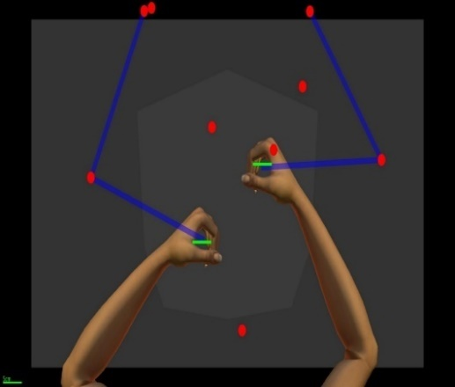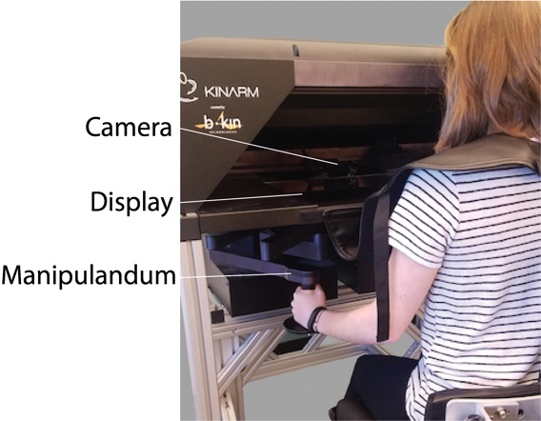**A B**

**Figure 3.1. Robotic apparatus and task.** Images of the KINARM robot (A) and Object Hit task (B).

* + 1. ***Task***

Participants performed a bimanual object hitting task, Object Hit, in which they used 5m wide virtual paddles attached to each hand to hit away 2 cm diameter red circles (n=300) that moved towards them from the top of the workspace (Fig. 2B). The goal of the task was to hit away as many red circles as possible. The task started with a single slow-moving circle and the number of circles and their movement speed increased over time. The task lasted a little over two minutes and released a total of 300 circles.

* + 1. ***Robotic measures***

Task performance was measured by computing ***Target Hits*** as the percent of targets that were successfully hit during the entire task.

Motor impairment was measured by computing ***Hand Speed Bias*** as the normalized difference in the average speed (S) of right- and left- hand movements, where:

***Hand Speed Bias* = (SR − SL) / (SR + SL)**

Visuospatial impairment was measured by computing ***Miss Bias*** as the normalized difference in the number of targets missed (M) on the left and right sides of the workspace.

***Miss Bias* = (MR − ML) / (MR + ML)**

* 1. **Analysis**
     1. ***Sensorimotor Network***

We examined a sensorimotor network comprised of eight cortical subnetworks and 30 ROIs from the AICHA atlas (**Table 3.1**, **Figure 3**).

**Table 3.1.** List of motor network of 30 ROIs within eight cortical regions

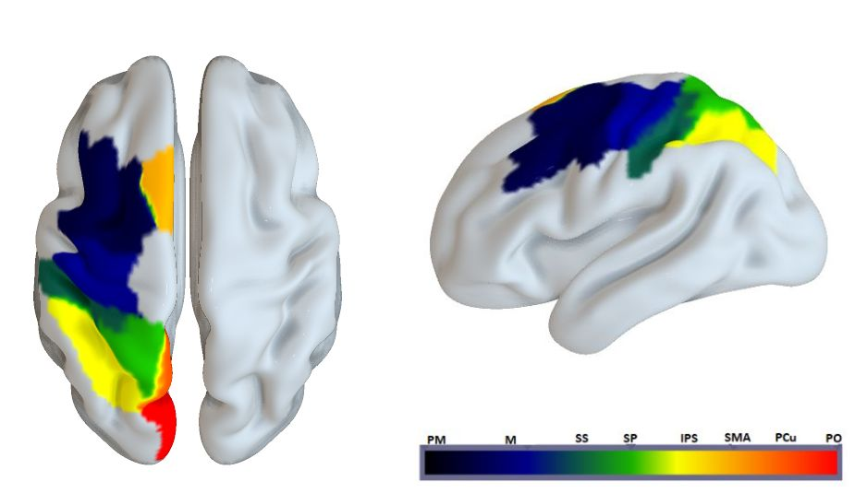**Figure 3.2. Sensorimotor network comprised of eight distinct subnetworks.** ***PM***: Premotor, ***M***: Motor, ***SS***: Somatosensory, ***SPL***: Superior Parietal, ***IPS***: Intraparietal Sulcus, **SMA**: Supplementary Motor Area, **PCu**: Precuneus, **Po**: Superior parieto-occipital cortex.

* + 1. ***Independence of behavioral measurements***

Relationships between behavioral measurements (**Hypothesis 1**) was examined between task performance, motor impairment and visuospatial impairment. Correlations was performed between Miss Bias, Hand Speed Bias, and Target Hit scores.

* + 1. ***Independence cortical damage and disconnection***

Relationships between cortical damage and disconnection (**Hypothesis 2**) was examined on ROIs that have at least 5% damage in nine or more participants. Correlations was performed on the average *Lesion Volume* and *Connectivity Bias* of theROIs in each of the eight subnetworks. In order to compute the Connectivity Bias for each subnetwork, the Connectivity Bias of each ROI in each subnetwork with all other ROIs was averaged (29).

* + 1. ***Lesion-symptom mapping***

To address Hypotheses 3-5, we examined relationships between cortical damage and robotic measures of motor impairment (**Hypothesis 3**), visuospatial impairment (**Hypothesis 4**) and task performance (**Hypothesis 5**) using ROI-based lesion symptom mapping (RLSM) on each of the 30 ROIs that has at least 5% damage in nine or more participants. Correlations was computed between: 1) *Lesion Volume* and *Hand Speed Bias*, 2) *Lesion Volume* and *Miss Bias*, and 3) *Lesion Volume* and *Target Hits*. Correlation coefficients was converted to z-scores using Fisher’s *r*-to-*z* transform and correlations was considered significant at a threshold *z*-score of 2.144, which corresponds to an *r2* = 0.10 (*r* = 0.32).

We also examined relationships between cortical disconnection and robotic measures of motor impairment (**Hypothesis 3**), visuospatial impairment (**Hypothesis 4**) and task performance (**Hypothesis 5**) using connectome-based lesion-symptom mapping (CLSM) on all 435 ROI-pairs in the sensorimotor network. Correlations was computed between: 1) *Connectivity Bias* and *Hand Speed Bias*, 2) *Connectivity Bias* and *Miss Bias*, and 3) *Connectivity Bias* and *Target Hits*. Correlation coefficients was converted to z-scores using Fisher’s *r*-to-*z* transform and, due to the small sample size, correlations was considered significant at a threshold *z*-score of 2.144, which corresponds to an *r2* = 0.10 (*r* = 0.32). Data visualization was carried out using SurfIce and Circro.

Learning from previous studies, for both lesion-based and connectome-based analyses we used a conservative threshold of about 20% (5% damage in nine or more participants across the sample size) to assure we only keep regions that are informative. (Yourganov and Rorden, 2016, Achilles et al., 2017)

**CHAPTER 4**

**Results**

**4.1. Participant characteristics**

Behavioral assessments were performed on 57 stroke survivors. Ten stroke survivors were excluded because they failed to meet our inclusion and exclusion criteria. **Table 4**.**1** summarizes the demographic and clinical data for the remaining 47 participants.

**Table 4**.**1.** Summary of Demographic and clinical Data.

|  |  |  |  |  |
| --- | --- | --- | --- | --- |
| **Measure** | **# Subjects** | **Range** | **Median** | **IQR** |
| Age | 47 | 37-80 | 60 | 54-65 |
| Sex | 47 | 33M,14F | – | – |
| Handedness | 46 | 39R,7L | – | – |
| Time Since Stroke (Months) | 47 | 8-234 | 25 | 13-76 |
| Box and Block - Right Hand (#) | 46 | 0-83 | 46 | 33-55 |
| Box and Block - Left Hand (#) | 46 | 33-80 | 53 | 45-57 |
| Modified Ashworth Scale - Right Elbow (0-5) | 26 | 0-2 | 0 | 0-1 |
| Modified Ashworth Scale - Right Wrist (0-5) | 26 | 0-2 | 0 | 0-0 |
| TULIA - Left Hand (0-12) | 27 | 6-12 | 11 | 10-12 |
| Visual Cognition Assessment (0-20) | 29 | 10-20 | 16 | 14-18 |
| Nottingham Sensory Assessment - Right (0-17) | 27 | 7-17 | 17 | 17-17 |
| Nottingham Sensory Assessment - Left (0-17) | 27 | 15-17 | 17 | 17-17 |
| Landmark Line Bisection (% Deviation) | 25 | -8-11 | 0 | -2-1 |
| Ota Letter Cancellation (0-20) | 26 | 19-20 | 20 | 19-20 |
| Stroke Impact Scale - Strength (0-20) | 45 | 7-20 | 14 | 13-16 |
| Stroke Impact Scale – Hand Function (0-25) | 45 | 5-25 | 21 | 17-25 |
| Stroke Impact Scale - Mobility (0-45) | 45 | 25-80 | 41 | 35-44 |

**4.2. Lesion volume of participants**

**Figure 4.1** shows an overlay of the average mean lesion volume of the 47 participants. The lesion overlay shows that Postcentral Sulcus-3-L, Intraparietal Sulcus-1-L, Intraparietal Sulcus-2-L, Superior Parietal Gyrus-4-L had the highest lesion volumes with close to 20% damage, on average.

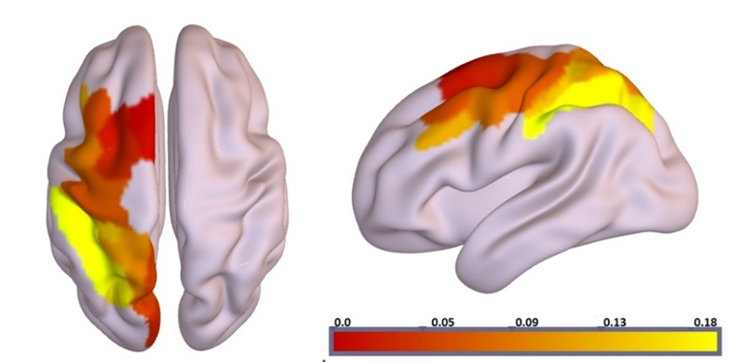

**Figure 4.1.** **Lesion overlay in standard space from all participants**. The colored regions exhibit the percent of lesion among the 47 participants.as yellow color represented the highest lesion volume % across all sample and dark red represented the lowest Lesion volumes %.

**4.3. Relationships between behavioral measurements**

To examine relationships between task performance, motor impairment and visuospatial impairment (**Hypothesis 1**), we computed correlations between *Miss Bias*, *Hand Speed Bias*, and *Target Hits*. We did not observe significant correlations between *Miss Bias* and *Hand Speed Bias* (**Figure 4.2*A***) or *Miss Bias* and *Target Hits* **(Figure 4.2*B***), but we did observe a significant correlation between *Target Hits* and *Hand Speed Bias* **(Figure 4.2*C*)**.

**4.4. Relationships between cortical damage and disconnection**

To examine the relationship between cortical damage and disconnection (**Hypothesis 2**), we computed correlations between mean *Lesion Volume* and mean *Connectivity Bias* in the eight sensorimotor subnetworks. We observed moderate to strong correlations in the premotor, motor, somatosensory, superior parietal, intraparietal sulcus, precuneus subnetworks **(Figure 4.3**). However, we did not observe correlations in supplementary motor area and superior parietooccipital cortex.

**4.5. Relationships between cortical damage and motor impairment**

To examine the relationships between cortical damage and motor impairment (**Hypothesis 3**), we computed correlations between *Lesion Volume* and *Hand Speed Bias*. We observed weak negative correlations between *Lesion Volume* and *Hand Speed Bias* in the motor subnetwork (Rolando Sulcus 2L, Rolando Sulcus 3L) and somatosensory subnetworks (Postcentral Sulcus 2L, Postcentral Sulcus 3L) (**Figure 4.4**), but none of the 30 ROIs surpassed the threshold z-score of 2.144.

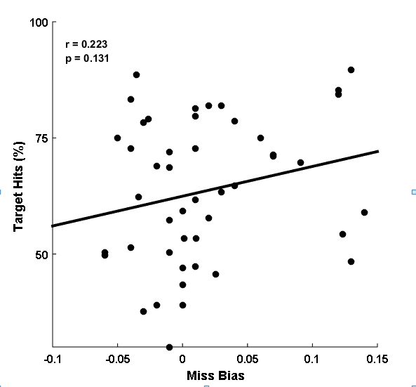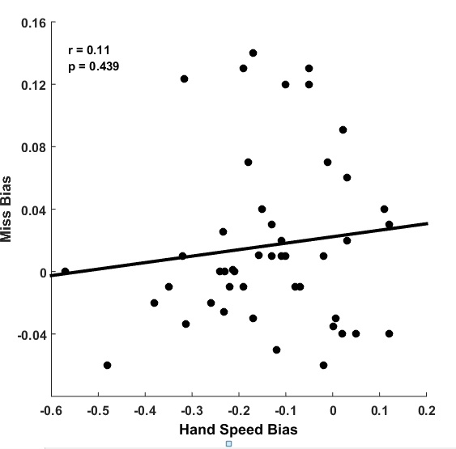**A B**

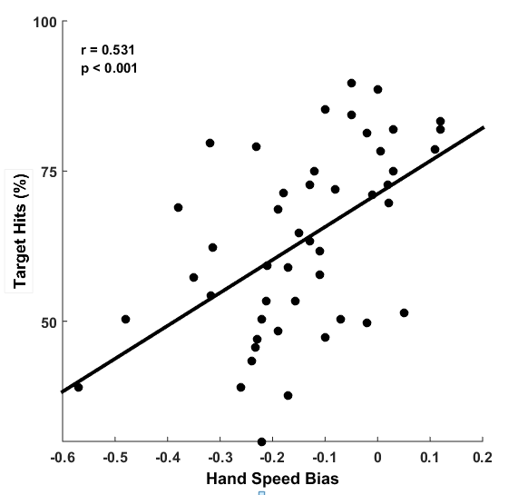**C**

**Figure 4.2.** **Relationships between behavioral measures.**

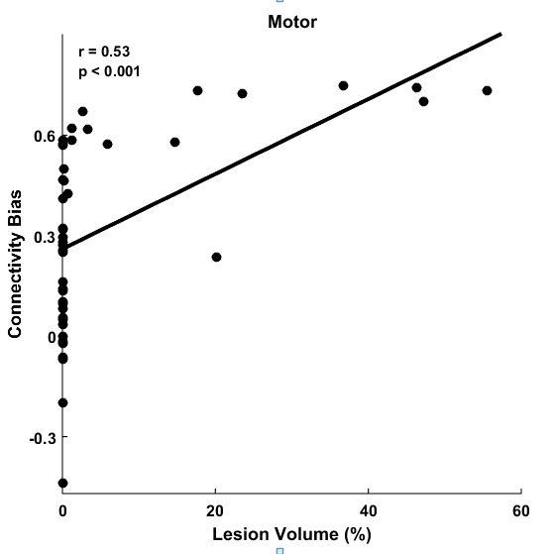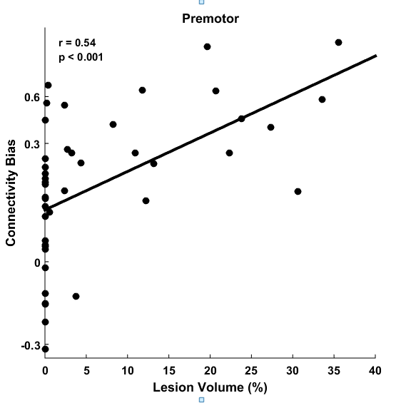**A B**

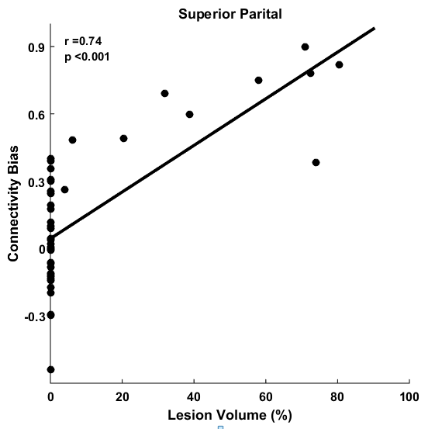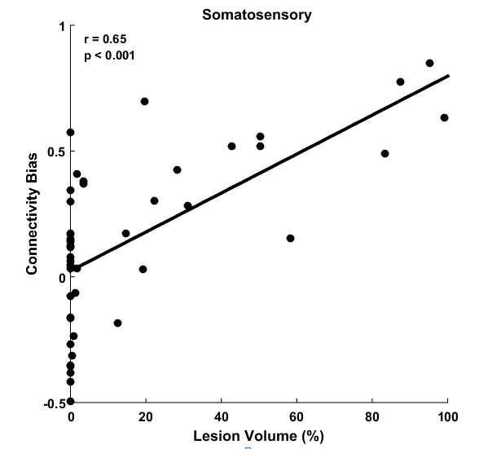**C D**

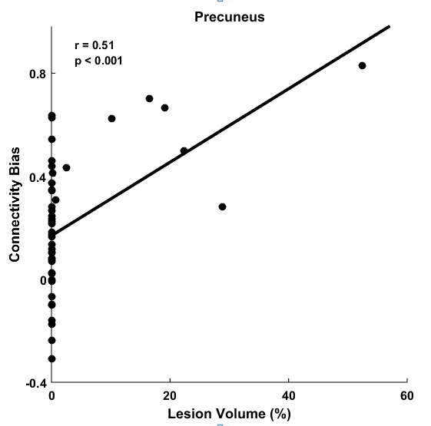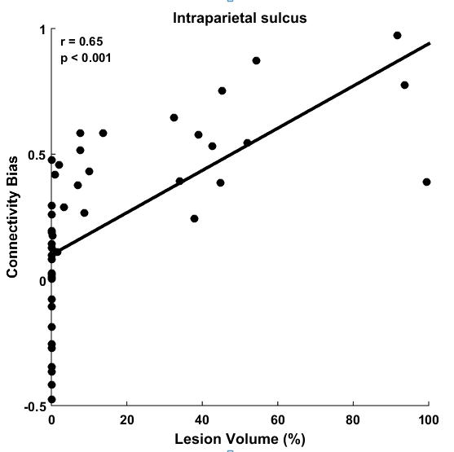**E F**

**Figure 4.3. Relationships between cortical damage and disconnection.** Scatter plots showing significant correlations between *Lesion Volume* and *Connectivity Bias* for the premotor (***A***), motor (***B***), somatosensory (***C***), superior parietal (***D***), intraparietal (***E***), and precuneus (***F***) subnetworks.

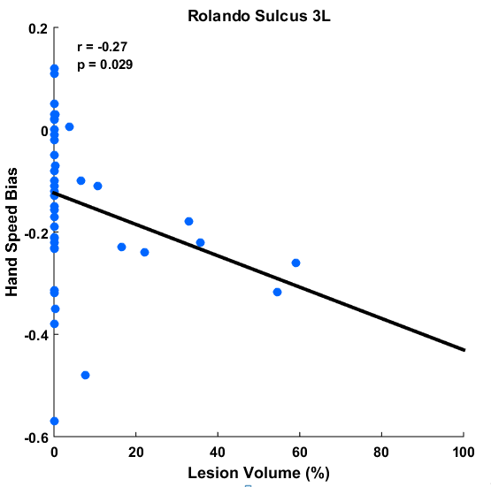**A B**

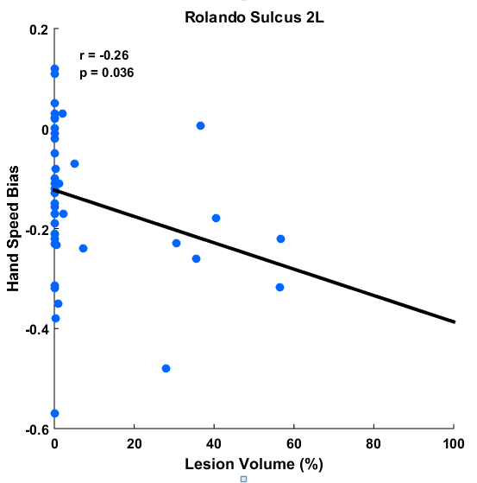**Figure 4.4. Relationships between cortical damage and motor impairment.** Scatter plots showing weak correlations between *Lesion Volume* and *Hand Speed Bias* for Rolando Sulcus 2L (***A***) and Rolando Sulcus 3L (***B***). Line shows the corresponding linear regression line.

**4.6. Relationships between cortical disconnection and motor impairment**

To examine the relationships between cortical disconnection and motor impairment (**Hypothesis 3**), we computed correlations between *Connectivity Bias* and *Hand Speed Bias* (**Figure 4.5**). We observed 32 different connections that surpassed the threshold z-score of 2.144. Each of the eight subnetworks had at least one significant connection, though 28 of the significant connections involved the premotor, motor, supplementary motor, somatosensory, and intraparietal subnetworks (**Figure 4.6)**.

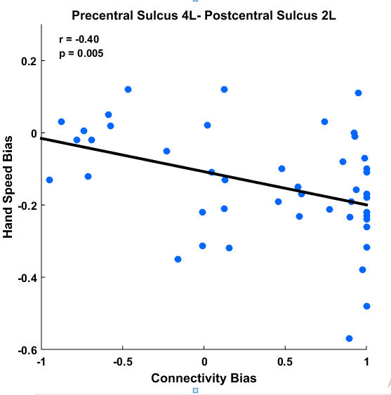**A B**

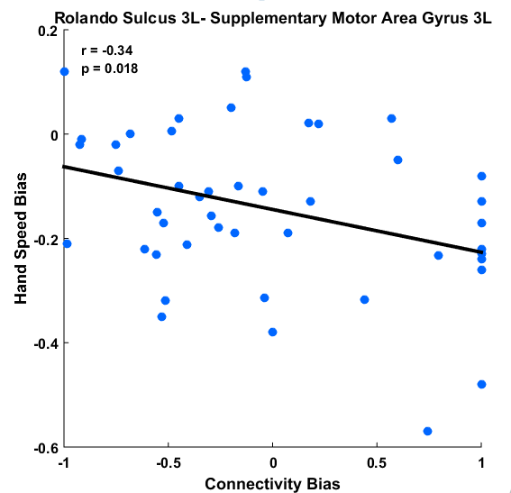**C**

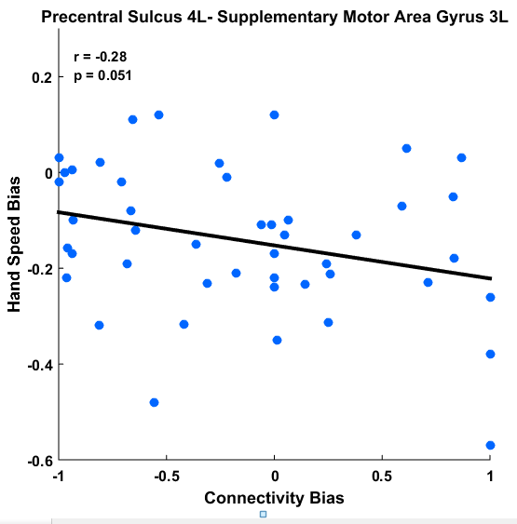**Figure 4.5. Relationships between cortical disconnection and motor impairment.** Scatter plots showing correlations between *Connectivity Bias* and *Hand Speed Bias* for connections between Rolando sulcus and supplementary motor area (***A***), precental sulcus and postcental sulcus (***B***), and precental sulcus and supplementary motor area (***C***).

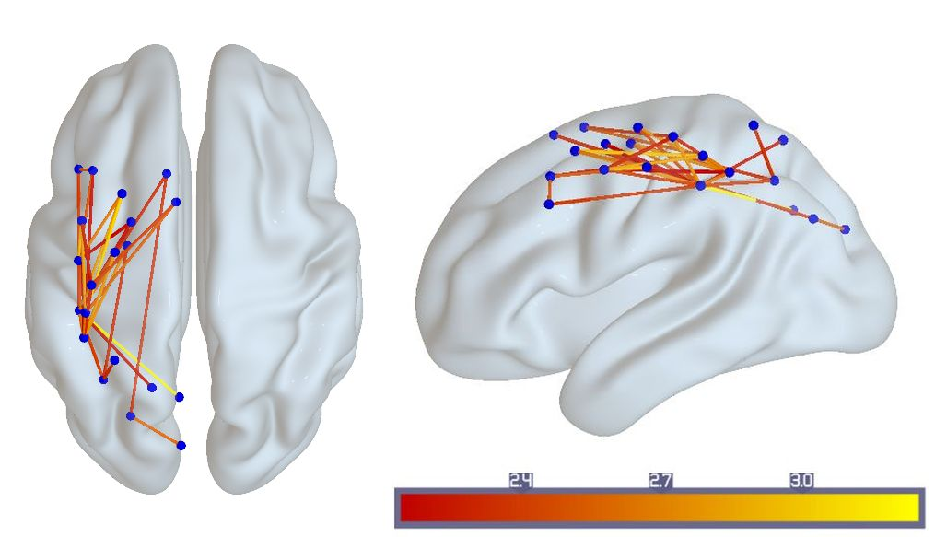**A**

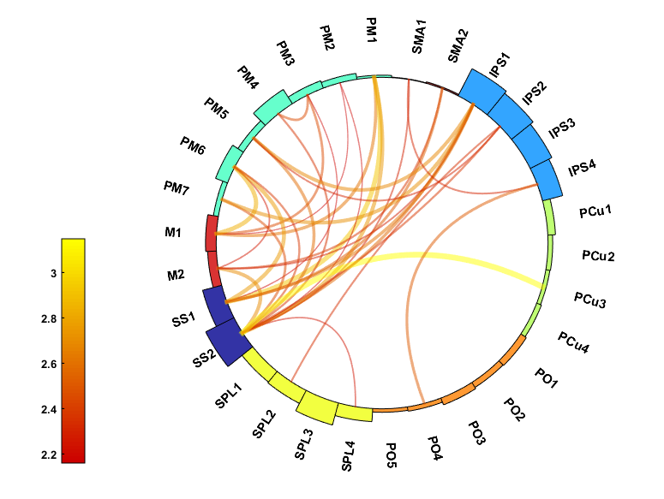**B**

**Figure 4.6. Connectome of cortical damage and motor impairment. *A***,Whole-brainconnectome showing all connections with significant correlations between *Connectivity Bias* and *Hand Speed Bias*. Each node (blue color) represents an ROI and each line represents a connection between ROIs. Only connections with z-scores above threshold (z = 2.144) are shown (see color bar). ***B*,** Circular diagrams showing all connections with significant correlations. See Table 1 for abbreviations.

**4.7. Relationships between cortical damage and visuospatial impairment**

To examine the relationships between cortical damage and visuospatial impairment (**Hypothesis 4**), we computed correlations between *Lesion Volume* and *Miss Bias*. Two ROIs within the intraparietal network (Intraparietal Sulcus 2L, Intraoccipital Sulcus 1L) had correlations that surpassed the threshold z-score of 2.144 (**Figure 4.7**).

**4.8. Relationships between cortical disconnection and visuospatial impairment**

To examine the relationships between cortical disconnection and visuospatial impairment (**Hypothesis 4**), we computed correlations between *Connectivity Bias* and *Miss Bias* (**Figure 4.8**). We observed 19 different connections that surpassed the threshold z-score of 2.144. Each of the eight subnetworks had at least one significant connection and all of the subnetworks except for the motor and somatosensory subnetworks had at least three significant connections (**Figure 4.8*C*,*D***).

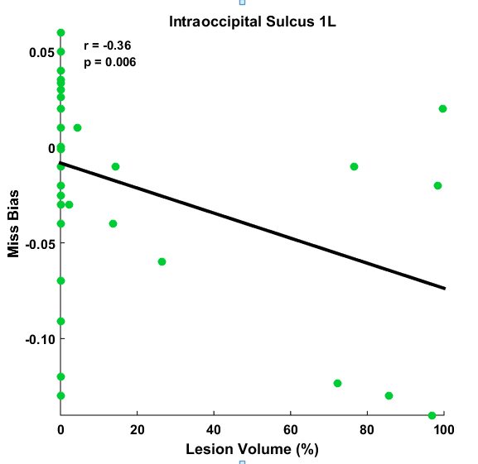**A B**

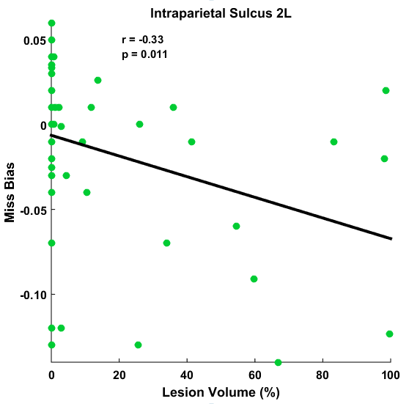**C**

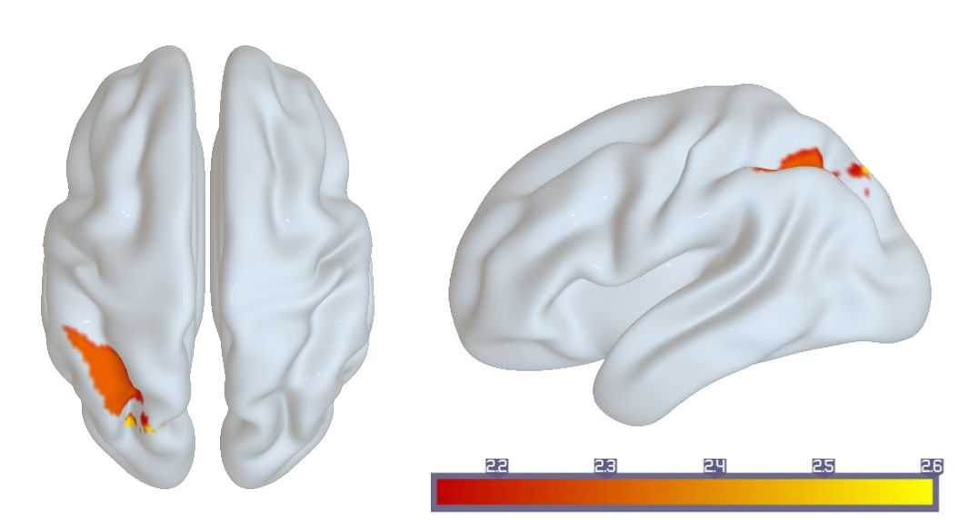

**Figure 4.7. Relationships between cortical damage and visuospatial impairment. *A*,*B*,** Scatter plots showing correlations between *Lesion Volume* and *Miss Bias* for Intraparietal Sulcus 2L (***A***) and Intraoccipital Sulcus 1L (***B***). Lines show the corresponding linear regression lines. **C,** Whole-brain illustration of ROIs with significant correlations. Only ROIs with z-scores above threshold (z = 2.144) are shown (see color bar).

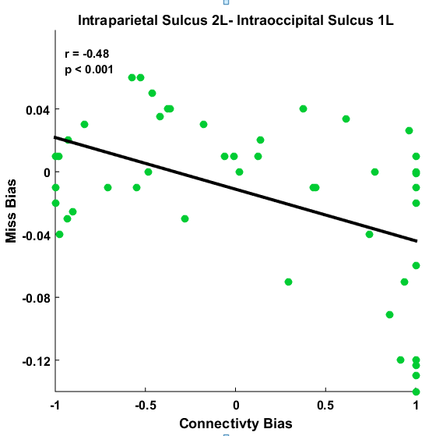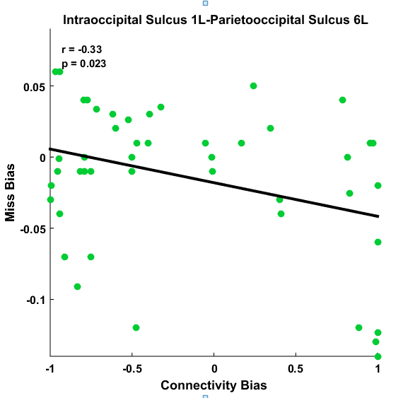**A B**

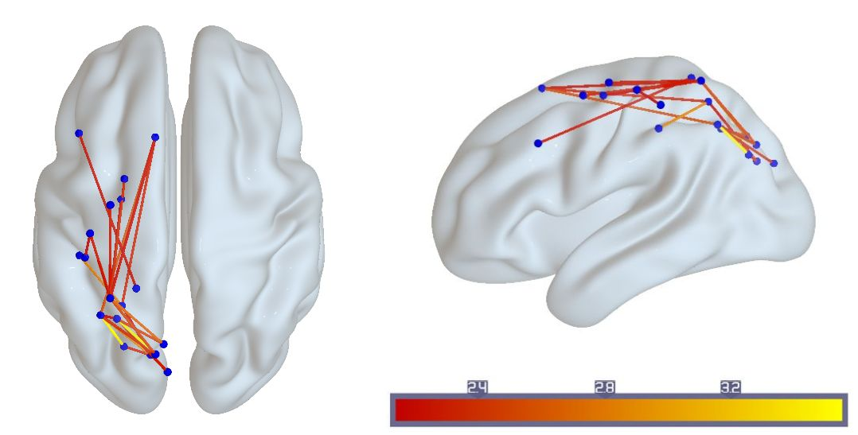**C**

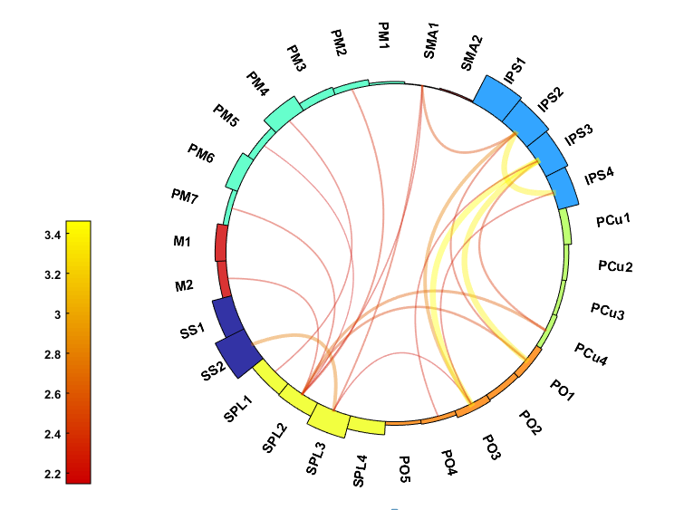**D**

**Figure 4.8 Relationships between cortical disconnection and visuospatial impairment. *A***,***B***,Scatter plots showing correlations between *Connectivity Bias* and *Miss Bias* for connections within intraparietal sulcus (***A***) and between intraparietal sulcus and superior parietooccipital cortex (***B***). ***C***, ***D***,Whole-brain (***C***) and circular (***D***) diagrams showing connections with significant correlations. Only connections with z-scores above threshold (z = 2.144) are shown (see color bar).

**4.9. Relationships between cortical damage and task performance**

To examine the relationships between cortical damage and task performance (**Hypothesis 5**), we computed correlations between *Lesion Volume* and *Target Hits*. Six ROIs within the motor, somatosensory, superior parietal and precuneus subnetworks had correlations that surpassed the threshold z-score of 2.144 (**Figure 4.9**).

**4.10. Relationships between cortical disconnection and task performance**

To examine the relationships between cortical disconnection and task performance (**Hypothesis 5**), we computed correlations between *Connectivity Bias* and *Target Hits* (**Figure 4.10**). We observed 43 different connections that surpassed the threshold z-score of 2.144. Each of the eight subnetworks had at least one significant connection and all of the subnetworks except for the precuneus and superior parietooccipital subjects had at least five significant connections (**Figure 4.10*C*,*D***). Together with the preceding relationships between cortical damage and task performance (see 4.7), our results show that global task performance was strongly correlated with both damage and disconnection of sensorimotor cortex.

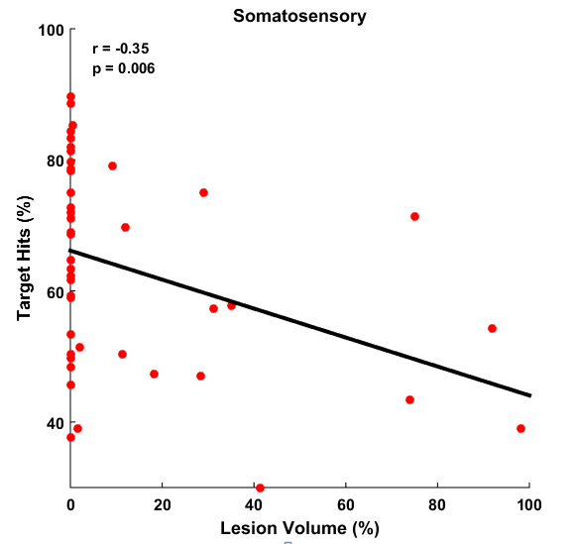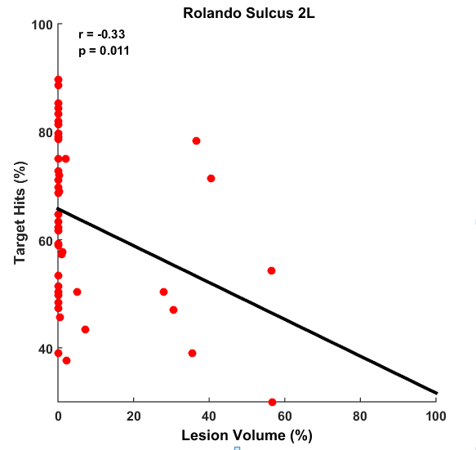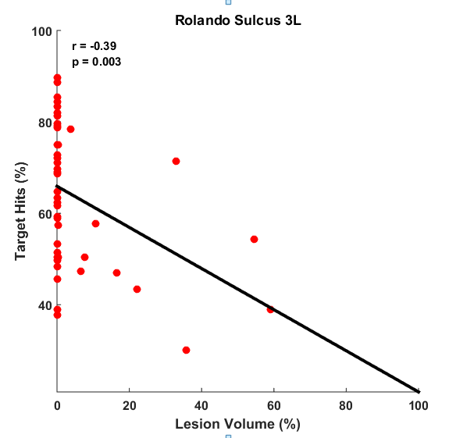**A B C**

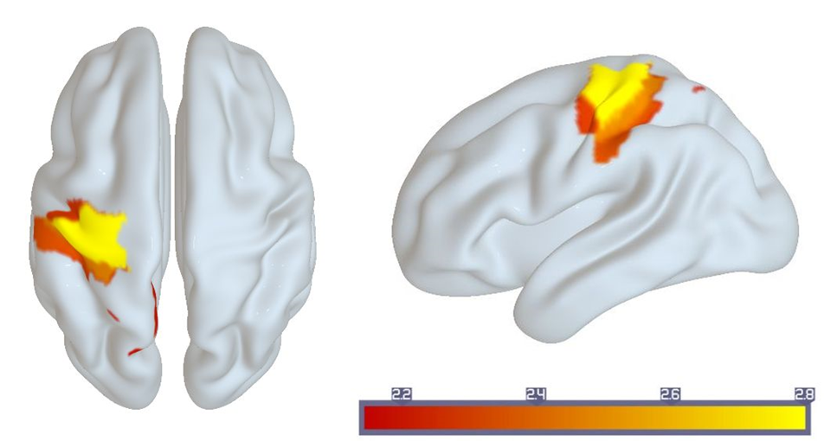**D**

**Figure 4.9 Relationships between cortical damage and task performance. *A*-*C,*** Scatter plots showing correlations between *Lesion Volume* and *Target Hits* for Rolando Sulcus 2L (***A***), Rolando Sulcus 3L (***B***), and Postcentral Sulcus 2L (***C***). Lines show corresponding linear regression lines. ***D,*** Whole-brain diagram showing all six ROIs with z-scores above threshold (z= 2.144).

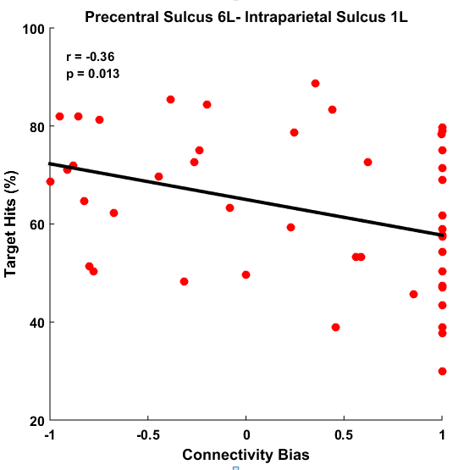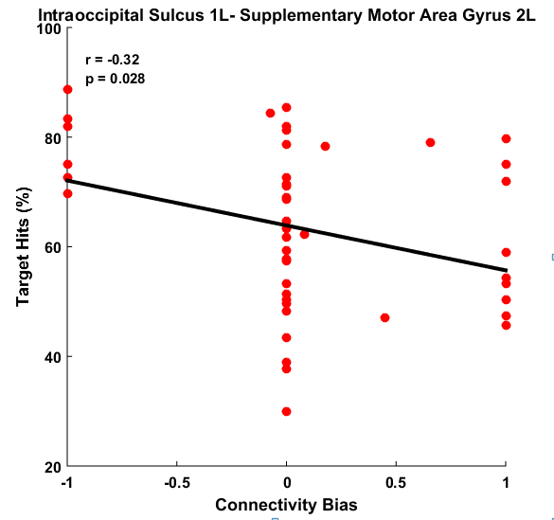**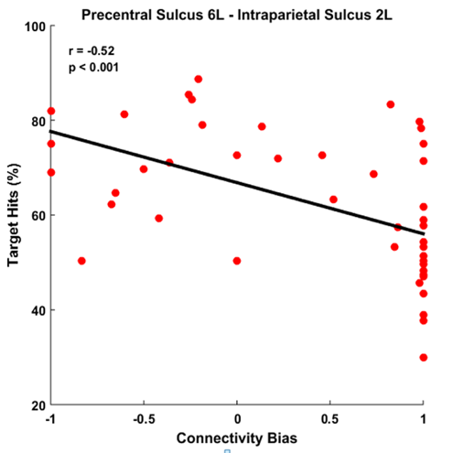A B C**

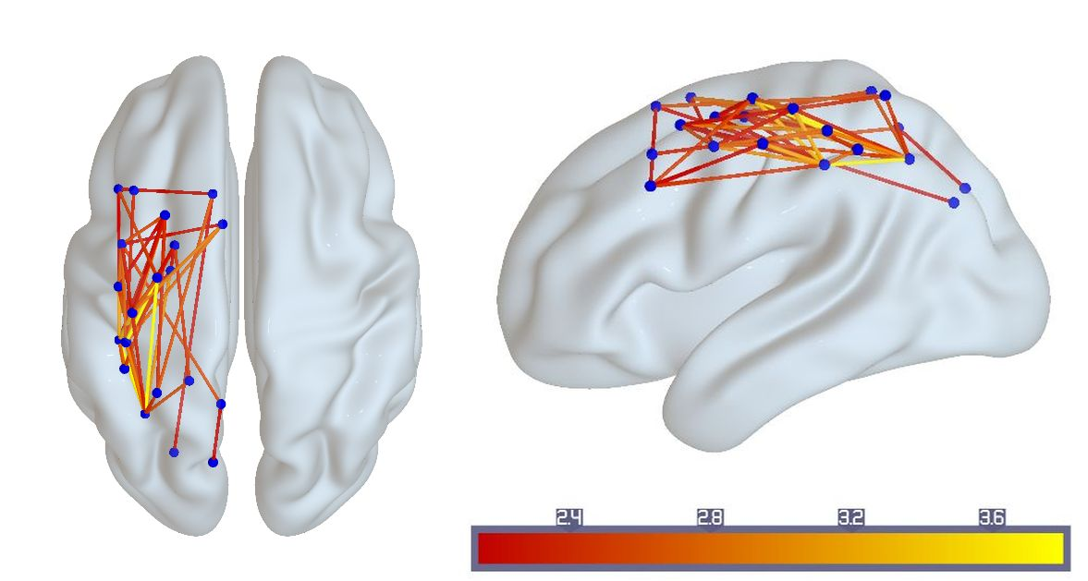**D**

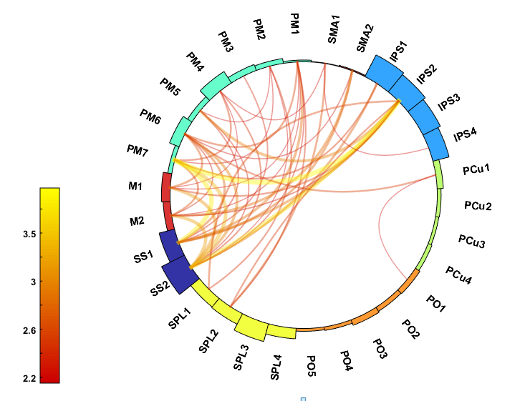**E**

**Figure 4.10 Relationships between cortical disconnection and task performance. *A*-*C*,** Scatter plots showing correlations between *Connectivity Bias* and *Target Hits* for frontoparietal connections. ***D*, *E*,** Whole-brain (***C***) and circular (***D***) diagrams showing connections with significant correlations. Only connections with z-scores above threshold (z = 2.144) are shown (see color bar)

**Chapter 5**

**Discussion**

**5.1. Prediction of motor outcomes from cortical damage and disconnection**

Integrating ROI-based and connectivity-based lesion-symptom mapping methods has the unique potential to answer questions about brain and behavior relationships. Coupling neuroimaging with robotic technology has further helped us to understand neurobiology of motor system. The aim of this study was to investigate the relationships between sensorimotor function and brain lesion and structural connectivity within sensorimotor cortex of individuals with stroke. Our results confirm that cortical damage and disconnection are complementary factors that can be used to predict sensorimotor deficits after stroke.

As expected, our results showed that deficits in task performance were associated with damage to several sensorimotor, cortical regions, including regions within our Motor (Rolando Sulcus-2-L, Rolando Sulcus-3-L), Somatosensory (Postcentral Sulcus-2-L, Postcentral Sulcus-3-L), Superior Parietal (Superior Parietal Gyrus-4-L), and Precuneus (Precuneus Gyrus-5-L) subnetworks. These findings complement previous studies linking superior parietooccipital cortex and anterior precuneus with reaching movements. (Kertzman et al., 1997; Gallivan et al., 2015) We also found that visuospatial impairments were associated with damage to our Intraparietal subnetwork (Intraparietal Sulcus-2-L, Intraoccipital Sulcus-1-L). Previous studies have highlighted that Intraparietal Sulcus plays an important role in processing visual information from grasp-related regions in both ventral and dorsal streams (Devare et al., 2011).

Our study revealed that motor impairment, visuospatial impairment and task performance were strongly associated with cortical disconnection of several regions. Cortical disconnection between Supplementary Motor Area and Somatosensory Cortex was significantly associated with both motor impairment and task performance. Previous studies have found that Supplementary Motor Area plays a crucial role in coordination and synchronization of bimanual movements and exerting control over voluntary actions involving response selection (Walsh et al., 2008; Nachev et al., 2007). Moreover, other studies have found that connectivity and integrity of Supplementary Motor Area can affect motor function of the upper extremities (Peters et al., 2018). Effective connectivity between Supplementary Motor Area and Primary Motor Cortex may play a crucial role in performing motor tasks (Bajaja et al., 2015). In addition, Hand Speed Bias has been shown to be an excellent for quantifying asymmetries in reaching movement (Tyryshkin et al. 2014). Therefore, our results support previous studies and confirm that Hand Speed Bias is an excellent measure of bimanual coordination in the Object Hit task. Our findings also explain the association between disconnection of Supplementary Motor Area and deficits in task performance. Since overall task performance requires a distinct circuit of brain regions to execute and control the movement, the role of retaining intact connectivity of Supplementary Motor Area with Motor Cortex (Rolando Sulcus) and Somatosensory Cortex (Postcentral Sulcus) may be critical for retaining high levels of motor performance.

We observed that disruption of structural connectivity of Superior Parietal Gyrus with Motor Cortex (Rolando Sulcus), Somatosensory Cortex (Postcentral Sulcus) and Premotor Cortex (Superior Frontal Sulcus, Middle Frontal Gyrus) was strongly associated with visuospatial impairments in stroke patients. Moreover, disconnection of Intraparietal Sulcus with Parietooccipital Sulcus was strongly associated with visuospatial impairments. These findings provide support to the premise that the Superior Parietal Cortex and Intraparietal Sulcus work together to support purposeful actions like reaching and grasping by processing visual information about the position and motion of objects (Peters et al., 2015). Our findings also are in agreement with previous studies which have observed lower functional connectivity of visuospatial networks with decreased executive control in stroke patients compared to healthy adults (Almeida et al., 2017).

We studied the relationship between cortical damage and disconnection in the motor network. Although our processing controlled for direct effects of lesions on connectivity, we observed that lesion volumes within the Premotor, Motor, Somatosensory, Superior Parietal, Intraparietal subnetworks were significantly correlated with disconnection of corresponding cortical regions. This confirms that damage to brain regions is linked to a reduction in structural connectivity of the region. Although brain cortical damage is associated with disconnection, dynamic alterations in structural connectivity of brain regions could exist in regions distant from lesion location. These cortical regions which are intact but actually exhibit reduced structural connectivity may contribute to functional impairments and clinical symptoms and affect recovery after stroke (Bonilha et al., 2014). Our observation in the ROI-based and connectome-based analyses support the findings that damage to Motor Cortex (Rolando Sulcus) was strongly correlated with motor impairments (**Figure 4.4*B***). However, disconnection of Motor Cortex (Rolando Sulcus) and Supplementary Motor Area had moderate correlation with motor impairments (**Figure 4.5*A***). In addition, damage to Premotor Cortex (Precentral Sulcus-4-L) was not correlated with motor impairments, although disconnection of Premotor (Precentral Sulcus-4-L) and Somatosensory (Postcentral Sulcus-2-L) Cortex was strongly correlated with motor impairments (**Figure 4.5*B***) Furthermore, we found that damage to Intraparietal Cortex (Intraoccipital Sulcus-1-L, Intraparietal Sulcus-1-L) was strongly associated with visuospatial impairments (**Figure 4.6*A,B***). Disconnection of these two regions was also strongly correlated with visuospatial impairments. However, disconnection of Intraoccipital Sulcus-1-L and Parietooccipital Sulcus-6-L had only a weak correlation with Miss Bias (**Figure 4.7*A,B***). These observations suggest that cortical disconnection may be a better predictor of functional motor impairment and should be included in lesion-symptom mapping studies. Several studies have indicated that post-stroke motor impairment is associated with lesion size (Schiemanck et al., 2006; Page et al., 2013; Sterr et al., 2014). However, recent studies have demonstrated that lesion volume alone is not a good predictor of chronic motor impairment after the stroke, and that cortical disconnection can help explain some of the variability in limb-motor function (Peters et al., 2018). These results are in line with our findings, which showed that disconnection is stronger factor in identifying functional impairments.

We found Miss Bias was not significantly correlated with either Hand Speed Bias or Target Hits. However, Target Hits and Hand Speed Bias were highly correlated (**Figure 4.2**). This supports the notion that Miss Bias and Hand Speed Bias and Target Hits are independent measures (Tyryshkin et al. 2014). This may reflect that Target Hits is more dependent on Hand Speed Bias than Miss Bias. However, this may also reflect a lack of variability in Miss Bias scores due to the fact that we only included subjects with left-sided damage, whereas right-sided damage is typically associated with visuospatial impairments.

**5.2. Limitations**

This study has several limitations that need to be considered. First, damage to ROIs was widely dispersed within our sensorimotor network. There were few lesions to certain brain regions such as Supplementary Motor Area and Superior Parietooccipital Cortex in our sample. Therefore, we did not include several ROIs in our ROI-based lesion-symptom mapping analysis. Second, we only included cortical regions because of difficulties performing tractography due to challenges performing accurate normalization of subcortical regions. Obviously, subcortical regions such as the basal ganglia, cerebellum, and thalamus are greatly involved in motor control, but were not included in our study. Third, limitations of DTI tractography, such as the possibility of regions with fiber complexity and crossing, may have influenced the current results. Lastly, since this study was part of a larger study with sample of individual with speech and language impairments, the majority of participants had minimal motor impairment. Future studies with a boarder distribution of motor impairments will enable better examination of the effects of structural damage and disconnection on motor performance.

**5.3. Future directions**

The results of this study showed the importance of investigating brain damage and cortical disconnection in motor network in chronic stroke. Cortical disconnection is a complementary factor to brain lesion that contributes to the severity of motor impairments and impacts the recovery after stroke. Understanding the mechanisms of brain reorganization and structural alteration after stroke can provide more insight into post-stroke recovery and plasticity. The next step is to develop a prognostic method that can examine and predict post-stroke recovery. This will assist with the identification of patients with greater potential for recovery and with selecting the best appropriate interventions for individual patient based on their structural brain connectome and damage. Future research should also include the application of innovative treatments such as transcranial magnetic stimulation to examine the training-induced neural plasticity and potential changes in functional and structural connectivity for better target therapeutic interventions to increase post stroke motor recovery.

**References**

Achilles, E. I., Weiss, P. H., Fink, G. R., Binder, E., Price, C. J., & Hope, T. M. (2017). Using multi-level Bayesian lesion-symptom mapping to probe the body-part-specificity of gesture imitation skills. NeuroImage, 161, 94-103.

Almeida, S. R. M., Vicentini, J., Bonilha, L., Campos, B. M., Casseb, R. F., & Min, L. L. (2017). Brain connectivity and functional recovery in patients with ischemic stroke. Journal of Neuroimaging, 27(1), 65-70.

Asai, T., Sugimori, E., & Tanno, Y. (2010). Two agents in the brain: motor control of unimanual and bimanual reaching movements. PloS One, 5(4), e10086.

Ashburner, J., & Friston, K. J. (2005). Unified segmentation. Neuroimage, 26(3), 839-851.

Bajaj, S., Butler, A. J., Drake, D., & Dhamala, M. (2015). Brain effective connectivity during motor-imagery and execution following stroke and rehabilitation. NeuroImage: Clinical, 8, 572-582.

Bates, E., Wilson, S. M., Saygin, A. P., Dick, F., Sereno, M. I., Knight, R. T., & Dronkers, N. F. (2003). Voxel-based lesion–symptom mapping. Nature neuroscience, 6(5), 448.

Behrens, T. E. J., Johansen-Berg, H., Woolrich, M. W., Smith, S. M., Wheeler-Kingshott, C. A. M., Boulby, P. A., & Thompson, A. J. (2003). Non-invasive mapping of connections between human thalamus and cortex using diffusion imaging. Nature neuroscience, 6(7), 750.Behrens, T. E., Berg, H. J., Jbabdi, S., Rushworth, M. F., & Woolrich, M. W. (2007). Probabilistic diffusion tractography with multiple fiber orientations: What can we gain? Neuroimage, 34(1), 144-155.

Bohannon RW, Smith MB. (1987). Interrater reliability of a modified Ashworth scale of muscle spasticity. Physical therapy, 67, 206-207.

Bonilha, L., Nesland, T., Rorden, C., Fillmore, P., Ratnayake, R. P., & Fridriksson, J. (2014). Mapping remote subcortical ramifications of injury after ischemic strokes. Behavioural neurology, 2014.

Chen, J. L., & Schlaug, G. (2013). Resting state interhemispheric motor connectivity and white matter integrity correlate with motor impairment in chronic stroke. Frontiers in neurology, 4, 178.

Cisek, P., & Kalaska, J. F. (2010). Neural mechanisms for interacting with a world full of action choices. Annual review of neuroscience, 33, 269-298.

Coderre, A. M., Zeid, A. A., Dukelow, S. P., Demmer, M. J., Moore, K. D., Demers, M. J., ... & Bagg, S. D. (2010). Assessment of upper-limb sensorimotor function of subacute stroke patients using visually guided reaching. Neurorehabilitation and neural repair, 24(6), 528-541.

Connell, L. A., Lincoln, N. B., & Radford, K. A. (2008). Somatosensory impairment after stroke: frequency of different deficits and their recovery. Clinical rehabilitation, 22(8), 758-767.

Corbetta, M., Ramsey, L., Callejas, A., Baldassarre, A., Hacker, C. D., Siegel, J. S., et al. (2015). Common behavioral clusters and subcortical anatomy in stroke. Neuron, 85(5), 927-941.

Davare, M., Kraskov, A., Rothwell, J. C., & Lemon, R. N. (2011). Interactions between areas of the cortical grasping network. Current opinion in neurobiology, 21(4), 565-570.

Duncan P, Wallace D, Lai S, Johnson D, Embretson S, Laster L. (1999). The stroke impact scale version 2.0.: Evaluation of reliability, validity, and sensitivity to change. Stroke, 30, 2131-2140.

Einav, O., Geva, D., Yoeli, D., Kerzhner, M., & Mauritz, K. H. (2011). Development and validation of the first robotic scale for the clinical assessment of upper extremity motor impairments in stroke patients. Topics in stroke rehabilitation, 18, 587-598.

Findlater, S. E., Desai, J. A., Semrau, J. A., Kenzie, J. M., Rorden, C., Herter, T. M., et al. (2016). Central perception of position sense involves a distributed neural network–Evidence from lesion-behavior analyses. Cortex, 79, 42-56.

Frey, S. H., Fogassi, L., Grafton, S., Picard, N., Rothwell, J. C., Schweighofer, N., et al. (2011). Neurological principles and rehabilitation of action disorders: computation, anatomy, and physiology (CAP) model. Neurorehabilitation and neural repair, 25, 6S-20S.

Hagmann, P., Cammoun, L., Gigandet, X., Meuli, R., Honey, C. J., Wedeen, V. J., & Sporns, O. (2008). Mapping the structural core of human cerebral cortex. PLoS biology, 6(7), e159.

Handy, T. C., Borg, J. S., Turk, D. J., Tipper, C. M., Grafton, S. T., & Gazzaniga, M. S. (2005). Placing a tool in the spotlight: spatial attention modulates visuomotor responses in cortex. NeuroImage, 26(1), 266-276.

Gallivan, J. P., & Culham, J. C. (2015). Neural coding within human brain areas involved in actions. Current opinion in neurobiology, 33, 141-149.

Georgopoulos, A. P., Kalaska, J. F., & Massey, J. T. (1981). Spatial trajectories and reaction times of aimed movements: effects of practice, uncertainty, and change in target location. Journal of Neurophysiology, 46(4), 725-743.

Geyer, S., Matelli, M., Luppino, G., & Zilles, K. (2000). Functional neuroanatomy of the primate isocortical motor system. Anatomy and Embryology, 202(6), 443-474.

Gleichgerrcht, E., Fridriksson, J., Rorden, C., & Bonilha, L. (2017). Connectome-based lesion-symptom mapping (CLSM): a novel approach to map neurological function. NeuroImage: Clinical, 16, 461-467.

Harvey M, Milner AD, Roberts RC. (1995). An investigation of hemispatial neglect using the Landmark Task. Brain and Cognition, 27, 59-78.

Jaeger, L., Marchal-Crespo, L., Wolf, P., Riener, R., Michels, L., & Kollias, S. (2014). Brain activation associated with active and passive lower limb stepping. Frontiers in human neuroscience, 8, 828.

Joliot, M., Jobard, G., Naveau, M., Delcroix, N., Petit, L., Zago, L., et al. (2015). AICHA: an atlas of intrinsic connectivity of homotopic areas. Journal of neuroscience methods, 254, 46-59.

Kantak, S., Jax, S., & Wittenberg, G. (2017). Bimanual coordination: A missing piece of arm rehabilitation after stroke. Restorative neurology and neuroscience, 35(4), 347-364.

Kertzman, C., Schwarz, U., Zeffiro, T. A., & Hallett, M. (1997). The role of posterior parietal cortex in visually guided reaching movements in humans. Experimental Brain Research, 114(1), 170-183.

La Fougere, C., Zwergal, A., Rominger, A., Förster, S., Fesl, G., Dieterich, M., et al. (2010). Real versus imagined locomotion: a [18F]-FDG PET-fMRI comparison. Neuroimage, 50(4), 1589-1598.

Lee, M. H., Shin, Y. I., Lee, S. H., Cha, Y. J., Kim, D. Y., Han, B. S., & You, S. H. (2015). Diffusion tensor imaging to determine the potential motor network connectivity between the involved and non-involved hemispheres in stroke. Bio-medical materials and engineering, 26, S1447-S1453.

Lim, J. S., & Kang, D. W. (2015). Stroke connectome and its implications for cognitive and behavioral sequela of stroke. Journal of stroke, 17(3), 256.

Lincoln NB, Jackson JM, Adams SA. (1998). Reliability and revision of the Nottingham sensory assessment for stroke patients. Physiotherapy, 84, 358-365.

Lindenberg, R., Renga, V., Zhu, L. L., Betzler, F., Alsop, D., & Schlaug, G. (2010). Structural integrity of corticospinal motor fibers predicts motor impairment in chronic stroke. Neurology, 74(4), 280-287.

Makris, N., Kennedy, D. N., McInerney, S., Sorensen, A. G., Wang, R., Caviness Jr, V. S., & Pandya, D. N. (2004). Segmentation of subcomponents within the superior longitudinal fascicle in humans: a quantitative, in vivo, DT-MRI study. Cerebral Cortex, 15(6), 854-869.

Marteniuk, R. G. (1987). Constraints on human arm movement trajectories. Canadian Journal of Psychology, 41, 365.

Martin, M., Dressing, A., Bormann, T., Schmidt, C. S., Kümmerer, D., Beume, L., et al. (2016). Componential network for the recognition of tool-associated actions: evidence from voxel-based lesion-symptom mapping in acute stroke patients. Cerebral Cortex, 27(8), 4139-4152.

Mathiowetz V, Volland G, Kashman N, Weber K. (1985). Adult norms for the Box and Block Test of manual dexterity. Am J Occ Ther, 39, 386-91.

Nachev, P., Coulthard, E., Jäger, H. R., Kennard, C., & Husain, M. (2008). Enantiomorphic normalization of focally lesioned brains. Neuroimage, 39(3), 1215-1226

Nasreddine, Z. S., Phillips, N. A., Bédirian, V., Charbonneau, S., Whitehead, V., Collin, I., et al. (2005). The Montreal Cognitive Assessment, MoCA: a brief screening tool for mild cognitive impairment. Journal of the American Geriatrics Society, 53(4), 695-699.

Oldfield, R. C. (1971). The assessment and analysis of handedness: the Edinburgh inventory. Neuropsychologia, 9(1), 97-113.

Ota H, Fujii T, Suzuki K, (2001). Dissociation of body-centered and stimulus-centered representations in unilateral neglect. Neurology.;57:2064-2069

Page, S. J., Gauthier, L. V., & White, S. (2013). Size doesn't matter: cortical stroke lesion volume is not associated with upper extremity motor impairment and function in mild, chronic hemiparesis. Archives of physical medicine and rehabilitation, 94(5), 817-821.

Peters, D. M., Fridriksson, J., Stewart, J. C., Richardson, J. D., Rorden, C., Bonilha, L., & Fritz, S. L. (2018). Cortical disconnection of the ipsilesional primary motor cortex is associated with gait speed and upper extremity motor impairment in chronic left hemispheric stroke. Human brain mapping, 39(1), 120-132.

Peters, S., Handy, T. C., Lakhani, B., Boyd, L. A., & Garland, S. J. (2015). Motor and visuospatial attention and motor planning after stroke: considerations for the rehabilitation of standing balance and gait. Physical therapy, 95(10), 1423-1432.

Proto, D., Pella, R. D., Hill, B. D., & Gouvier, W. (2009). Assessment and rehabilitation of acquired visuospatial and proprioceptive deficits associated with visuospatial neglect. NeuroRehabilitation, 24(2), 145-157.

Rehme, A. K., Eickhoff, S. B., Rottschy, C., Fink, G. R., & Grefkes, C. (2012). Activation likelihood estimation meta-analysis of motor-related neural activity after stroke. Neuroimage, 59(3), 2771-2782.

Reinkensmeyer, D. J., Emken, J. L., & Cramer, S. C. (2004). Robotics, motor learning, and neurologic recovery. Annu. Rev. Biomed. Eng., 6, 497-525.

Rorden, C., Bonilha, L., Fridriksson, J., Bender, B., & Karnath, H. O. (2012). Age-specific CT and MRI templates for spatial normalization. Neuroimage, 61(4), 957-965

Rorden, C., Karnath, H. O., & Bonilha, L. (2007). Improving lesion-symptom mapping. Journal of cognitive neuroscience, 19(7), 1081-1088.

Schiemanck, S. K., Post, M. W. M., Witkamp, T. D., Kappelle, L. J., & Prevo, A. J. H. (2005). Relationship between ischemic lesion volume and functional status in the 2nd week after middle cerebral artery stroke. Neurorehabilitation and neural repair, 19(2), 133-138.

Schulz, R., Koch, P., Zimerman, M., Wessel, M., Bönstrup, M., Thomalla, G., ... & Hummel, F. C. (2015). Parietofrontal motor pathways and their association with motor function after stroke. Brain, 138(7), 1949-1960. doi: 10.1093/brain/awv100

Scott, S. H. (2004). Optimal feedback control and the neural basis of volitional motor control. Nature Reviews Neuroscience, 5(7), 532.

Scott, S. H., Dukelow, S. P. (2011). Potential of robots as next-generation technology for clinical assessment of neurological disorders and upper-limb therapy. Journal of rehabilitation research and development, 48(4), 335.

Schulz, R., Braass, H., Liuzzi, G., Hoerniss, V., Lechner, P., Gerloff, C., & Hummel, F. C. (2015). White matter integrity of premotor–motor connections is associated with motor output in chronic stroke patients. Neuroimage: Clinical, 7, 82-86. doi: 10.1016/j.nicl.2014.11.006

Shadmehr, R., & Mussa-Ivaldi, F. A. (1994). Adaptive representation of dynamics during learning of a motor task. Journal of Neuroscience, 14(5), 3208-3224

Singh T, Fridriksson J, Perry C, Tryon SC, Ross A, Fritz S, Herter TM. A novel computational model to probe visual search deficits during motor performance. J Neurophysiol, 117, 79-92, 2016.

Sterr, A., Dean, P. J., Szameitat, A. J., Conforto, A. B., & Shen, S. (2014). Corticospinal tract integrity and lesion volume play different roles in chronic hemiparesis and its improvement through motor practice. Neurorehabilitation and neural repair, 28(4), 335-343.

Stinear, C. M., Barber, P. A., Smale, P. R., Coxon, J. P., Fleming, M. K., & Byblow, W. D. (2006). Functional potential in chronic stroke patients depends on corticospinal tract integrity. Brain, 130(1), 170-180.

Takakusaki, K. (2017). Functional neuroanatomy for posture and gait control. Journal of movement disorders, 10(1), 1.

Tyryshkin, K., Coderre, A. M., Glasgow, J. I., Herter, T. M., Bagg, S. D., Dukelow, S. P., & Scott, S. H. (2014). A robotic object hitting task to quantify sensorimotor impairments in participants with stroke. Journal of neuroengineering and rehabilitation, 11(1), 47.

Wahl, M., Lauterbach-Soon, B., Hattingen, E., Jung, P., Singer, O., Volz, S., et al. (2007). Human motor corpus callosum: topography, somatotopy, and link between microstructure and function. Journal of Neuroscience, 27(45), 12132-12138.

Walsh, R. R., Small, S. L., Chen, E. E., & Solodkin, A. (2008). Network activation during bimanual movements in humans. Neuroimage, 43(3), 540-553.

**APPENDIX A-TABLES OF LESION SYMPTOM MAPPING RESULTS**

Significant results of correlational analysis of cortical damage and behavioral measurements are showed in these two tables. Numbers in the tables represent the Fisher z-scores. Threshold *z*-score of 2.144 was considered as significant.

|  |  |  |  |  |  |  |  |  |  |  |  |  |  |  |  |
| --- | --- | --- | --- | --- | --- | --- | --- | --- | --- | --- | --- | --- | --- | --- | --- |
| **Behavioral Measurements** | **ROI 15** | **ROI 17** | **ROI 25** | **ROI 27** | **ROI 53** | **ROI 57** | **ROI 61** | **ROI 65** | **ROI 67** | **ROI 73** | **ROI 75** | **ROI 79** | **ROI 81** | **ROI 83** | **ROI 85** |
| **Target Hits** | 0.00 | 0.59 | 0.00 | 0.00 | 1.13 | 1.75 | 0.00 | 2.281* | 2.745* | 2.463* | 2.328* | 1.62 | 1.61 | 2.277* | 2.11 |
| **Hand Bias Speed** | 0.00 | 0.45 | 0.10 | 0.23 | 1.22 | 0.34 | 0.00 | 1.80 | 1.89 | 1.66 | 1.71 | 0.06 | 0.59 | 0.57 | 0.28 |
| **Miss Bias** | 0.00 | 0.00 | 0.87 | 0.31 | 0.00 | 0.00 | 0.00 | 0.13 | 0.62 | 0.86 | 0.72 | 1.53 | 1.22 | 1.15 | 1.12 |

|  |  |  |  |  |  |  |  |  |  |  |  |  |  |  |  |
| --- | --- | --- | --- | --- | --- | --- | --- | --- | --- | --- | --- | --- | --- | --- | --- |
| **Behavioral Measurements** | **ROI 109** | **ROI 111** | **ROI 113** | **ROI 115** | **ROI 223** | **ROI 225** | **ROI 273** | **ROI 275** | **ROI 277** | **ROI 279** | **ROI 287** | **ROI 291** | **ROI 293** | **ROI 295** | **ROI 297** |
| **Target Hits** | 1.57 | 1.48 | 2.07 | 1.26 | 0.00 | 0.00 | 2.205 | 0.00 | 0.00 | 0.00 | 0.00 | 0.00 | 0.00 | 0.00 | 0.00 |
| **Hand Bias Speed** | 1.09 | 0.77 | 1.10 | 1.10 | 0.00 | 0.00 | 0.00 | 0.00 | 0.00 | 0.00 | 0.00 | 0.00 | 0.00 | 0.00 | 0.00 |
| **Miss Bias** | 1.53 | 2.29* | 2.09 | 2.503* | 0.00 | 0.00 | 0.00 | 0.00 | 0.00 | 0.00 | 0.00 | 0.00 | 0.00 | 0.00 | 0.00 |

**APPENDIX B-TABLES OF CONNECTOME-BASED LESION SYMPTOM MAPPING RESULTS**

Significant results of correlational analysis of cortical disconnection and task performance (Threshold z-score =2.14).

|  |  |  |  |  |  |  |  |  |  |
| --- | --- | --- | --- | --- | --- | --- | --- | --- | --- |
| **ROIs Connectivity** | **Z-score** | **ROIs Connectivity** | **Z-score** | **ROIs Connectivity** | **Z-score** | **ROIs Connectivity** | **Z-score** | **ROIs Connectivity** | **Z-score** |
| **15-57** | 2.53 | **27-75** | 2.41 | **81-83** | 1.8623 | **111-81** | 2.4576 | **225-27** | 1.813 |
| **15-65** | 2.18 | **53-73** | 2.33 | **75-85** | 2.1031 | **113-53** | 1.7554 | **225-57** | 2.239 |
| **15-67** | 2.22 | **53-75** | 2.27 | **109-53** | 2.123 | **113-61** | 2.1005 | **225-65** | 1.69 |
| **15-73** | 2.83 | **57-65** | 2.63 | **109-61** | 2.4713 | **113-75** | 1.8904 | **225-67** | 2.815 |
| **15-75** | 2.26 | **57-67** | 2.27 | **109-75** | 2.6912 | **113-79** | 1.7821 | **225-73** | 2.733 |
| **15-81** | 2.38 | **57-73** | 2.69 | **109-81** | 1.6552 | **113-81** | 2.0049 | **225-79** | 1.658 |
| **17-53** | 2.19 | **57-75** | 2.92 | **111-53** | 2.9567 | **115-79** | 1.874 | **225-83** | 1.845 |
| **17-61** | 2.20 | **61-67** | 2.59 | **111-61** | 3.7746 | **223-27** | 2.2196 | **225-111** | 1.771 |
| **17-75** | 2.18 | **61-73** | 3.64 | **111-65** | 2.4817 | **223-67** | 1.8644 | **225-115** | 1.876 |
| **17-79** | 2.43 | **61-75** | 3.27 | **111-67** | 2.3148 | **223-79** | 1.8785 | **273-57** | 2.512 |
| **25-73** | 2.32 | **65-75** | 3.09 | **111-73** | 2.8542 | **223-81** | 2.5865 | **273-83** | 2.052 |
| **27-61** | 2.49 | **67-75** | 3.14 | **111-75** | 3.5645 | **223-113** | 1.8979 | **273-111** | 2.011 |
| **27-65** | 2.15 | **57-81** | 1.714 | **111-79** | 2.5568 | **223-115** | 2.1885 | **273-287** | 2.17 |

Significant results of correlational analysis of cortical disconnection and motor impairment (Threshold z-score =2.14).

|  |  |  |  |  |  |
| --- | --- | --- | --- | --- | --- |
| **ROIs Connectivity** | **Z-score** | **ROIs Connectivity** | **Z-score** | **ROIs Connectivity** | **Z-score** |
| **27-25** | 2.44 | **75-27** | 2.35 | **109-75** | 2.55 |
| **65-15** | 2.59 | **75-53** | 2.56 | **111-53** | 2.30 |
| **65-17** | 2.16 | **75-57** | 2.37 | **111-75** | 2.37 |
| **65-25** | 2.45 | **75-61** | 2.45 | **111-81** | 2.33 |
| **65-57** | 2.84 | **75-67** | 2.69 | **223-75** | 2.29 |
| **67-57** | 2.26 | **75-85** | 2.23 | **223-115** | 2.31 |
| **73-15** | 2.93 | **109-53** | 2.67 | **225-67** | 2.37 |
| **73-25** | 2.18 | **109-61** | 2.72 | **225-73** | 2.50 |
| **73-57** | 2.76 | **109-67** | 2.28 | **277-75** | 3.15 |
| **75-15** | 2.74 | **109-73** | 2.59 | **295-115** | 2.51 |
| **75-17** | 2.18 |  |  |  |  |

Significant results of correlational analysis of cortical disconnection and visuospatial impairment (Threshold z-score =2.14).

|  |  |  |  |
| --- | --- | --- | --- |
| **ROIs Connectivity** | **Z-score** | **ROIs Connectivity** | **Z-score** |
| **79-27** | 2.22 | **279-81** | 2.61 |
| **81-17** | 2.32 | **279-113** | 2.40 |
| **81-53** | 2.15 | **287-81** | 2.46 |
| **81-61** | 2.25 | **287-111** | 2.33 |
| **81-67** | 2.24 | **287-113** | 3.40 |
| **83-75** | 2.78 | **293-83** | 2.19 |
| **115-111** | 3.38 | **293-111** | 2.78 |
| **223-81** | 2.21 | **293-113** | 3.46 |
| **223-83** | 2.31 | **293-115** | 2.26 |